**IFT 266 Introduction to Network Information communication Technology (ICT)**

**Lab 40**

**IPv6 Troubleshooting**

Co-Authored by Joshua Brown

1. Open the file IPv6_Troubleshooting.pkt. Try pinging each computer. (PC1 → PC2, PC1→ PC3)

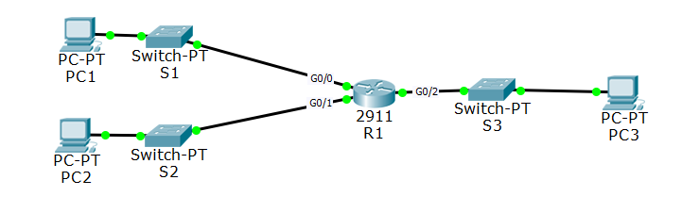



2. What do you notice is wrong with the topology?

_______________________________________________________________

Purpose of this lab is to troubleshoot the above network, figure out the problem and how to fix it.

Do not forget about the show commands!

3. What is causing the issue (s)?

_______________________________________________________________

_______________________________________________________________

4. What did you do to fix the issues?

_______________________________________________________________

_______________________________________________________________

**Note:** Do not use auto configuration to fix the problem.

5. Attach a screenshot of your two successful pings from PC1 → PC2 and PC1 → PC3 below.